Ex1:

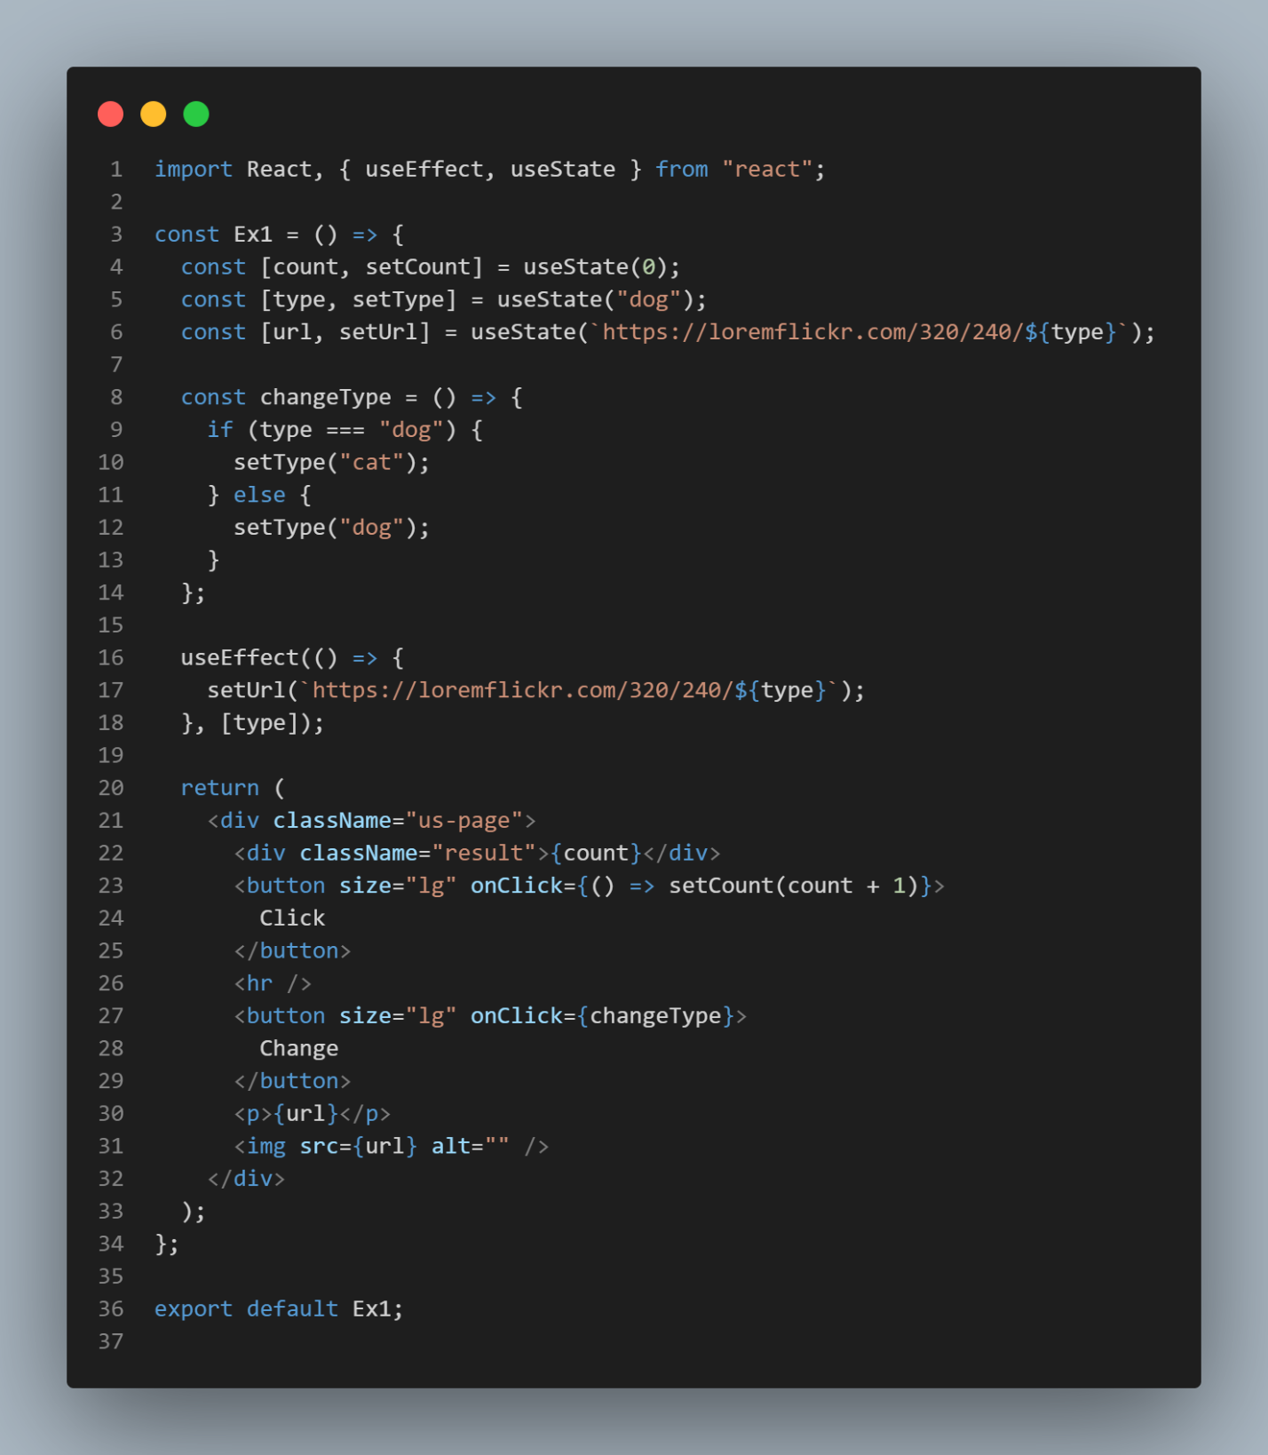

Here is result:

Ex11:

Here is result:

Ex 12:

Here is result:

Ex13:

Ex14:

Here is result:

Ex15:

Here is result:

Ex16:

Here is result:

Ex17:

Ex2:

GitHubLink: https://github.com/amenosakura/ReactVer2

